APPENDICES

Information and participation in the energy transition:
A case study on the frontiers of green hydrogen in Uruguay

Mariana Achugar, Carlos Santos, Irene Balado, Rodolfo Franco, Ana María Barbosa, Carlos Machado, Daniel Pena, Francesca Repetto, Gabriel Giordano, Matías Asconeguy, María Eugenia Riaño, Antonio Rey, Alicia Betina Acosta, Claudio Martínez-Debat, Pablo Díaz, Reto Bertoni, Daniela Guerra, Martha Chiappe, Ana Lía Ciganda, Sofia Maly, Nicolás Roballo, Constanza Martínez, Victoria Domínguez, Katerine Vieta, Tamara Mateu, Carla Freitas, Marco Fabila, María Fernanda Gómez, Nair Correa, Florencia Sciaraffia, Katherine Ramirez, Valentina González, Antonia Aloy, Vetiana Motta, Bruno Carbone, Guido Guinea, Ana Julia Liendo, Kimberley Tapie, Mara Fernández, Paola González, Sofia Mendieta, Belén Sosa, Bruno Abreu, Alain Vázquez.

Universidad de la República

Appendix 1: Sample design

Green hydrogen and the Tambor Project:
Perceptions and information among residents in the area of influence.

María Eugenia Riaño and Antonio Rey

The sample design for the selection of households in this study is complex and varies according to the availability of information for the localities in the area of interest. This means that different computer tools and sampling strategies must be used, depending on the type of auxiliary information that can be used. The following section presents the definition of the target population, the sampling frames, and the sample design itself, beginning with the definition of the strata, the designs used, and the sample sizes. Finally, the survey strategy and the results obtained in terms of response rates are described, concluding with the methodology used to calculate the sample weights.

1. Target Population
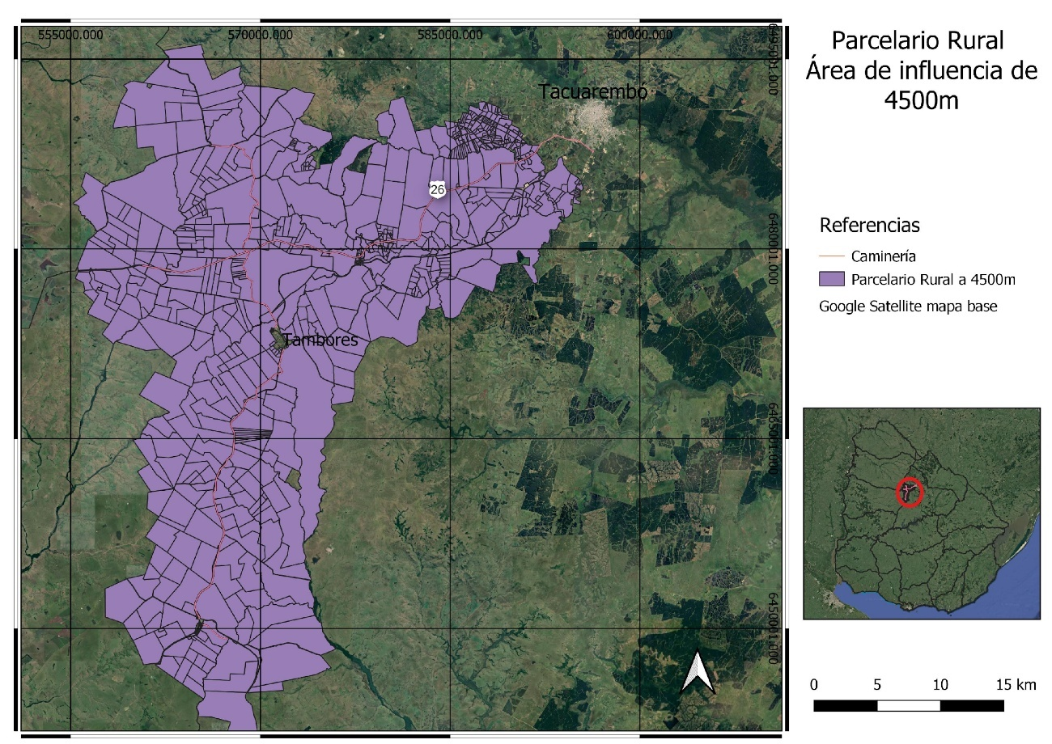
The population under study is the population residing in the geographical area shown in
Figure 1. A buffer area of 4,500 meters was determined along the main road between Tacuarembó and Piedra Sola, including the entire area affected by the project.

2. Sampling frame
The sampling frame varies according to stratification (which will be described in detail in the next section). The 2011 Population and Housing Census zone frame is used for localities recognized as such by the National Institute of Statistics (INE). For all other localities, information from Google Earth is used as the sampling frame, and for rural areas, a combination of rural cadastral parcel data and Google Earth information is used.
In cases where Google Earth is used, a visual inspection of potential dwellings is carried out, and it is not known a priori whether they are occupied by a household. This characteristic must be taken into account when conducting the housing lottery, mainly to define sample sizes, as it is not known whether the buildings detected are occupied by a household.

3. Sample Design
Stratification and sample sizes
As mentioned above, stratification is defined according to the availability of information for the localities within the study area. Six strata are thus constructed:
● Tambores (locality with census information)
● Piedra Sola (locality with census information)
● Rincón de la Aldea (locality not recognized in the 2011 Census)
● Los Rosanos (locality not recognized in the 2011 Census)
● Valle Edén (locality not recognized in the 2011 Census)
● Rural area.

The design varies by stratum according to the following details:
a) Stratums corresponding to Tambores and Piedra Sola
In these localities, a two-stage design is applied, in which the first stage involves selecting census areas (blocks) with probability proportional to size, according to the total number of dwellings according to the 2011 Census. In the second stage, a fixed number of dwellings per block is selected using a systematic design.
In the case of Tambores, there are a total of 75 blocks, of which 25 were selected. In each of these, five dwellings were selected, reaching a total of 125 dwellings selected (see selected blocks in Figure 2).
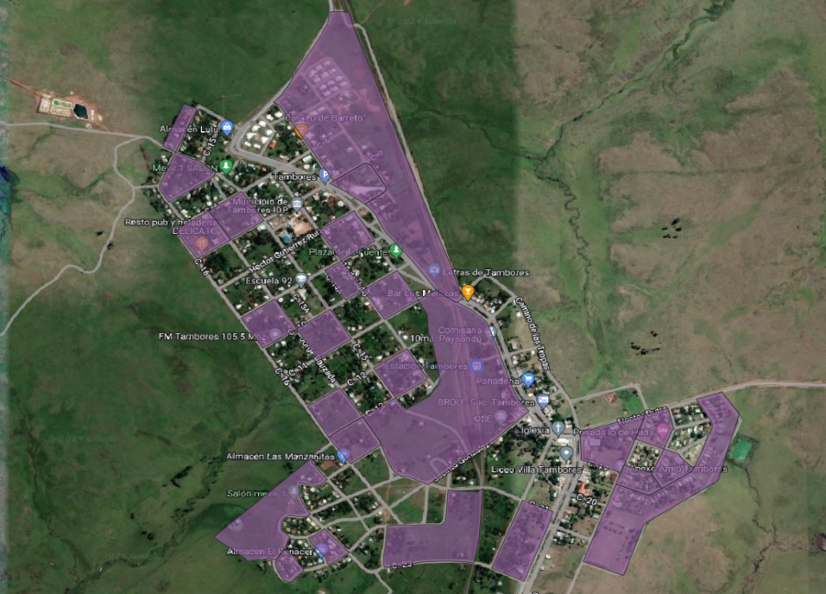
In Piedra Sola, there are a total of 24 blocks, of which 12 were selected. In each block, 4 dwellings were selected, resulting in a total sample of 48 dwellings (see selected blocks in Figure 3).

Figure 2: Selected blocks in the town of Tambores
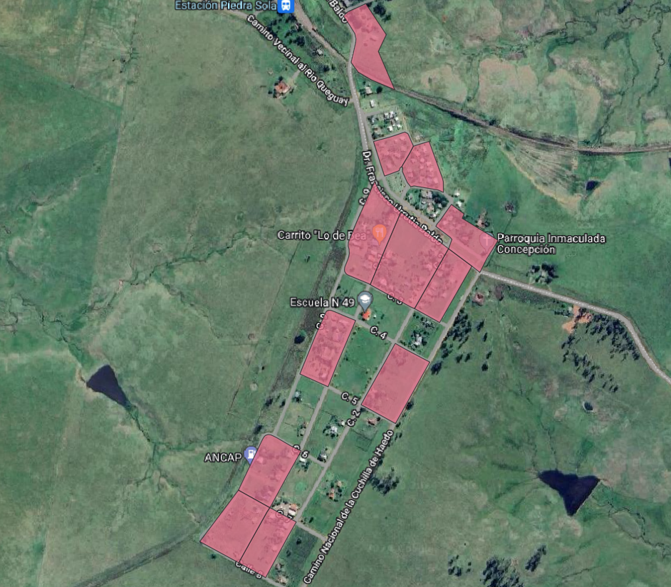
Figure 3: Selected blocks in the town of Piedra Sola

b) Strata corresponding to Los Rosanos and Valle Edén
As these localities were not recognized as such by the INE in 2011, there is no cartographic delimitation for them. In order to select the dwellings within these localities, a delimitation is created for each of them (see Figures 4 and 5). This delimitation is based on the rural parcel data of the General Directorate of Cadastre.
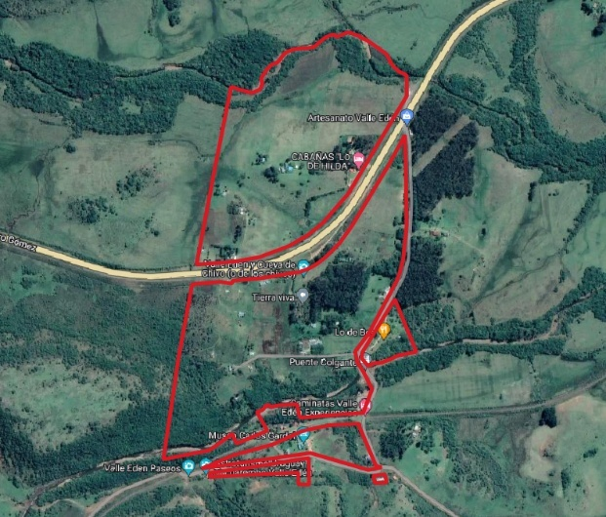
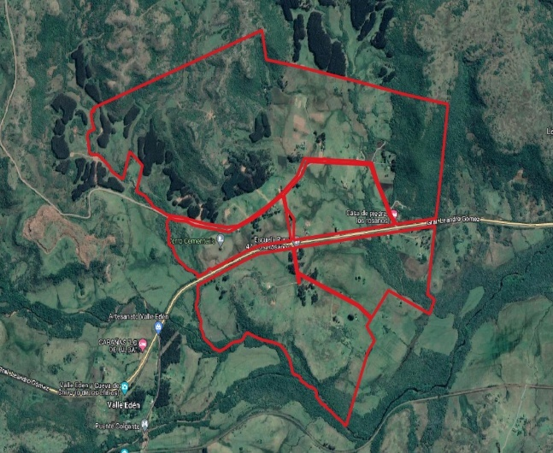
Once the localities have been delimited, the total number of dwellings/buildings is surveyed using Google Earth. In other words, each building or group of buildings is georeferenced using this tool, and then, from the total number of locations surveyed, the sample is selected using a simple random design.
Figure 4: Delimited area of Los Rosanos Figure 5: Delimited area of Valle Edén.
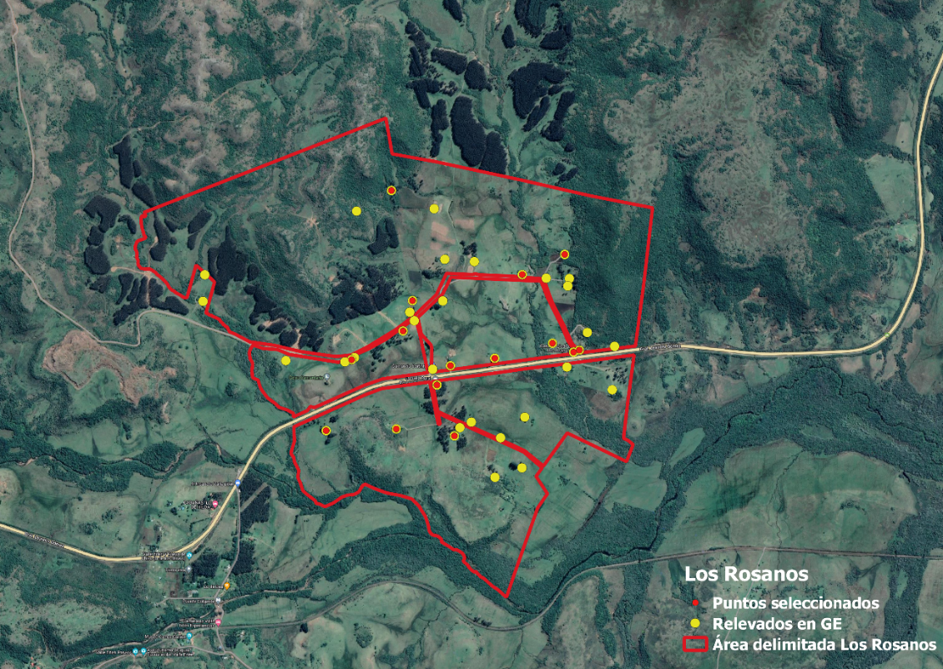
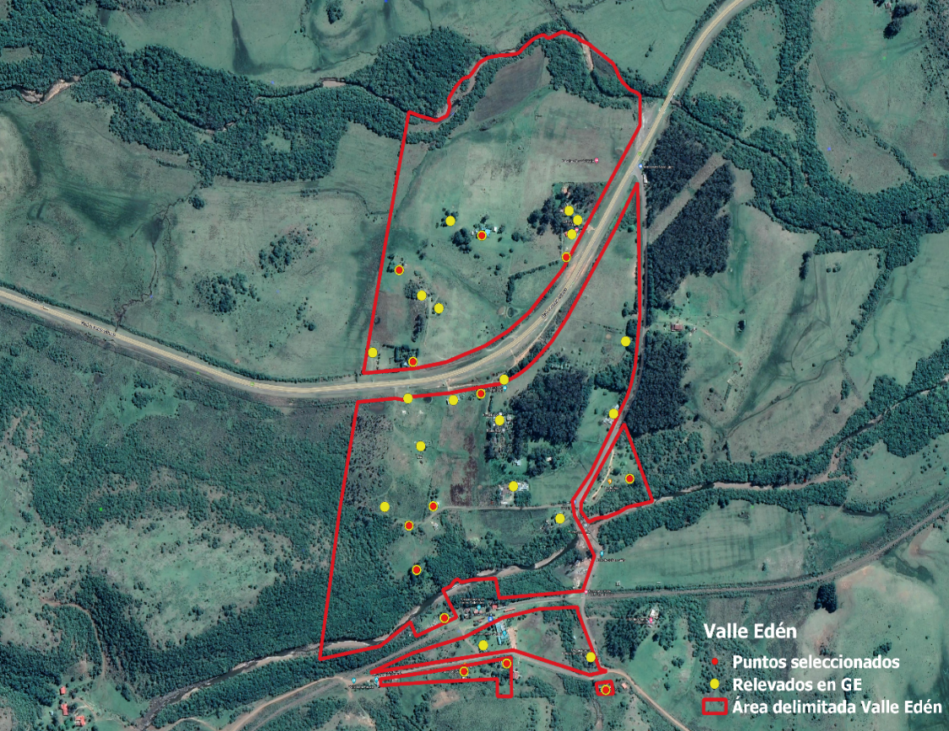
Figure 6: Points surveyed and selected in Los Rosanos.

Figure 7: Points surveyed and selected in Valle Edén
In Los Rosanos, 41 dwellings/buildings were identified (see Figure 6), of which 15 were selected. In Valle Edén, 32 dwellings/buildings were identified (see Figure 7), of which 13 were selected.

c) Rincón de la Aldea
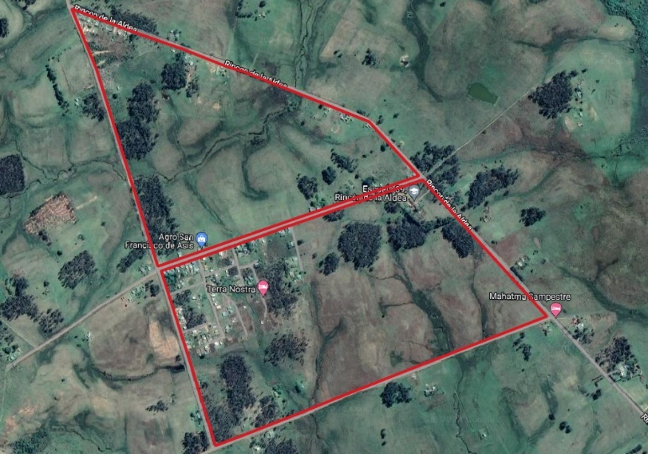
The area designated as Rincón de la Aldea is shown in Figure 8. In this particular case, there is a block-shaped area (see Figure 9) within the boundaries of the locality, where most of the dwellings are concentrated. A total of seven blocks are identified.
Figure 8: Delimited area of Rincón de la Aldea.
Figure 9: Selected areas within the boundaries of Rincón de la Aldea.
For the settled area, the blocks are marked on a map, and a two-stage design is applied, selecting blocks in the first stage (using a simple random design) and then dwellings using a systematic design, as in the cases of Tambores and Piedra Sola (see Figure 9). Three blocks are selected, and five dwellings in each block.
Figure 10: Selected points in Rincón de la Aldea

For the rest of the dwellings/buildings in the locality, the same design is applied as for Los Rosanos and Valle Edén. A total of 37 dwellings/buildings are surveyed, of which 10 are selected (see Figure 10).

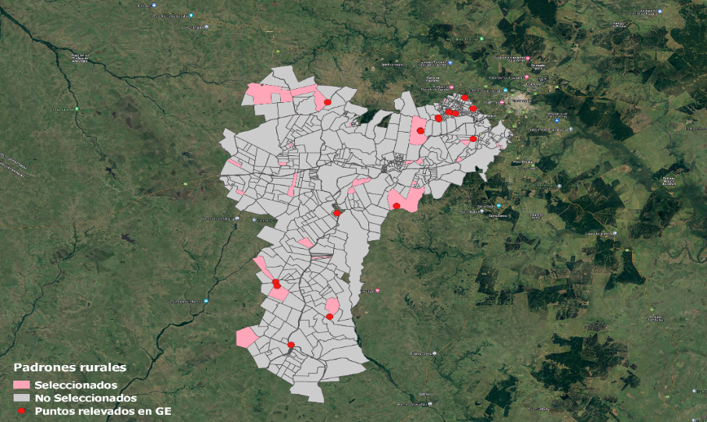
d) Rural areas

Figure 11: Selected rural catastral registers
In rural areas, cadastral registers are selected using a simple design, and the dwellings/buildings are then surveyed using Google Earth, in the same way as for the localities in point b). In this case, no random selection of dwellings is carried out, as the number of dwellings/buildings detected is very low. In other words, the final sample of rural dwellings is defined directly in the survey of the selected registers. To construct the rural register frame, those contained in the study area are selected, excluding those corresponding to the localities of Valle Edén, Los Rosanos, and Rincón de la Aldea.
A total of 40 rural registers were selected and 15 dwellings/buildings were found. The result is shown in Figure 11.

Margin of error associated with sample size
The sample size is therefore 242 households, and its distribution by locality is shown in Table 1.

Locality | Sample size
Tambores | 125
Piedra Sola | 48
Valle Edén | 13
Los Rosanos | 15
Rincón de La Aldea | 25
Rural | 15
Total | 242

Table 1: Distribution of sample size by locality.

The central parameters of interest are proportions, since the information collected is qualitative. The margin of error is calculated for a proportion, assuming maximum variance of the variable of interest, and that the confidence intervals to be estimated will be for 95%. Furthermore, since the total population residing in the study area is unknown, sampling with replacement is assumed. The formula for calculating the error is:

$$ε=z_{1-\frac{α}{2}}\sqrt{V(\hat{p})}=z_{1-\frac{α}{2}}\sqrt{\frac{p(1-p)}{n}}$$

where $z_{1-\frac{α}{2}}$ is the value associated with confidence intervals, which in this case will be assumed to be 95%, so $z_{1-\frac{α}{2}}$=1.96, and the value of p is 0.5, since this is the value for which the variance of the variable of interest is maximum. Substituting the above values into the formula, we obtain an associated margin of error of 6.3%.

$$ε=1.96\sqrt{\frac{0.5(1-0.5)}{242}}=0.063$$

4. Survey
Pilot survey
With the exception of rural areas, the survey was conducted in two stages. In the first stage, a preliminary survey was conducted with the aim of selecting dwellings in the surveyed areas, using a systematic design, and at the same time, as far as possible, determining whether the selected dwellings were occupied or did not correspond to a dwelling, for example in the case of commercial premises. This survey was conducted differently depending on the location:

In Tambores, Piedra Sola, and the block area of Rincón de la Aldea, systematic sampling was conducted on site of the dwellings in the selected blocks, with the aim of not leaving the final selection of the dwelling to the discretion of the interviewer. At this stage, the survey was carried out by those responsible for the project, so that when the interview was conducted, the interviewer already had the address of the dwelling where the interview would take place. According to the 2011 Census, there are 647 homes in the town of Tambores, of which only 484 are occupied. In the case of Piedra Sola, there are a total of 136 homes, of which only 76 are occupied. Although the Census is outdated, it is an indicator that there is a significant rate of unoccupied homes, so it is important to detect this situation prior to selecting the sample, so that the homes selected are actually occupied. This does not mean that all vacant dwellings are detected at this stage, but rather those where this situation is confirmed by observation or by information from residents in the area.
In Los Rosanos, Valle Edén, and the unmapped area of Rincón de la Aldea, the selection was made using GPS points, so only the status of the dwellings was surveyed: whether they were occupied or whether the construction detected did not correspond to a dwelling.

In rural areas, due to the difficulty of access, a single visit was made, during which the interview was conducted directly in cases where the dwelling/construction was occupied.
The number of unoccupied dwellings (VD) and non-corresponding cases (NC) in the pre-survey are presented in Table 2.

Locality | VD or NC
Tambores | 13
Piedra Sola | 0
Valle Edén | 2
Los Rosanos | 4
Rincón de La Aldea | 2
Rural | -
Total | 21

Table 2: Distribution of vacant or non-compliant dwellings by locality, detected in the preliminary survey.

Survey results
Once the preliminary survey stage is complete, the next stage involves visiting the households where the interviews will be conducted. At this stage, the interview results ranged among the following:
- Completed: meaning that a member of the household has answered the entire questionnaire. Resident Absent (MA): no one is found in the dwelling, but it is confirmed that a household resides there.
- Refusal: the person to be interviewed does not want to participate in the survey.
- Unoccupied dwelling (VD): it is confirmed that the dwelling is unoccupied.
- Other: other situations not covered by the above cases that do not correspond to occupied dwellings.

In cases where residents were absent, several visits were made at different times in order to maximize the response rate.
The results of the visits according to the above classification are presented in Table 3. For the calculation of the response rate, vacant dwellings and cases that do not correspond should not be taken into account, as they are not part of the target population. The response rate is then calculated as:
$$TR=\frac{H}{H+MA+R}=\frac{115}{115+46+18}=64.2\%$$

Table 3: Classification of visits by location.

The number of unoccupied dwellings and non-corresponding cases must be taken into account when calculating sample weights, adjusting the initial inclusion probabilities not only for non-response but also for the outdated frame, reflected in the high proportion of unoccupied dwellings.

Calculation of sample weights
Sample weights are calculated in accordance with the design used, as described in section I, and taking into account three types of adjustments: for outdated sampling frame, for non-response, and finally, calibrated by sex in order to mitigate response biases with respect to this variable.

Adjustment for sample frame obsolescence
Let $b_{i}$be the original weight of each household selected in the sample. The adjustment for sample frame obsolescence is made by multiplying the original weight by an adjustment factor, obtaining a new weight (or weighting factor) for the sample, which we will call $d_{i}$. The new weighting factor is obtained as follows:

$$d_{i}=b_{i}\frac{{\hat{N}}_{O}}{\hat{N}}$$

where ${\hat{N}}_{O}$ is the estimated total number of occupied dwellings and $\hat{N }$is the estimated total number of dwellings, with $\frac{{\hat{N}}_{O}}{\hat{N}}$being the estimated proportion of occupied dwellings. This adjustment term varies for each locality. Thus, the weight $d_{i}$ expands to the estimated total number of occupied dwellings in each locality.

Adjustment for non-response
The weight $d_{i}$ must be adjusted for non-response. The adjustment is also made by locality, obtaining a new weight, $p_{i}$, which is calculated as follows:

$$p_{i}=d_{i}\frac{1}{TR_{l}}$$

where $TR_{l}$ is the response rate by locality.

Calibration by gender
In the sample surveyed, the percentage of women is higher than in the population distribution. To correct this problem, a procedure is carried out to adjust the weighting of men and women according to information from the 2011 Census. As information is not available for the entire area, this is only done for the localities of Tambores and Piedra Sola. The result of this adjustment is that the expanded totals for men and women exactly reproduce the distribution of this variable according to the 2011 Census for these localities. Given that most of the sample is concentrated in these localities, the adjustment mitigates the greater weight of women in the sample, despite not being performed for localities where census information is not available.

Appendix 2: Survey
Encuesta Hidrógeno Verde y Proyecto Tambor
0 Código de zona _________________________
0.2 Código de casa ______________________
0.3 Número de encuesta (identificado en el papel) ___________________
0.4 Nombre/s de encuestador/a/es _______________________________________
1- ¿Cuántos años tienes? ___________________________
2- ¿Dónde resides?
- Tambores
- Piedra Sola
- Valle Edén
- Tacuarembó
- zonas rurales de Paysandú
- zonas rurales de Tacuarembó
- Otro lugar (indica cuál) __________

3- ¿Cuál es tu género?
- Mujer
- Varón
- Otro, indica cuál ______________________

4- ¿Cómo defines tu ascendencia? (marcar todas las opciones pertinentes)
- Afro o negra
- Indígena
- Asiática
- Europea
- Otra __________________________________________________

5- ¿Cuál consideras la principal? (elegir solo una opción)
- Afro o negra
- Indígena
- Asiática
- Europea
- Otra __________________________________________________

6- ¿A qué te dedicas principalmente? (marcar todas las opciones pertinentes)
- estudiante de secundaria
- estudiante nivel terciario
- empleado/a público/a
- empleado/a sector privado (no rural)
- trabajador/a rural asalariado/a (incluye trabajadores zafrales, pones y gerentes no propietarios)
- trabajador/a independiente (no rural, incluye "changas" o trabajos puntuales por cuenta propia)
- productor/a agropecuario/a (propietario/a, arrendatario/a y/o colono/a; ganadero, agrícola, hortícola, otros)
- trabajador/a no remunerado/a
- miembro de cooperativa de producción
- tareas del hogar – no remunerado
- jubilado/a o pensionista
- Otro __________________________________________________
7- ¿Cuál es el nivel educativo más alto alcanzado?
- Sin instrucción
- Primaria incompleta
- Primaria completa
- Secundaria incompleta (UTU, Secundaria o Agraria)
- Secundaria completa (UTU, Secundaria o Agraria)
- Terciaria incompleta (universitario y no universitario)
- Terciaria completa (universitario y no universitario)

8- ¿Consideras que tienes posibilidades para participar en la planificación y decisiones sobre proyectos en el territorio? (aclaración: espacios accesibles donde tener voz y voto sobre los proyectos que se desarrollan en el territorio de tipo público y privado)
- Sí
- No

9- ¿Has participado en alguna instancia o espacio convocado para pensar sobre el futuro de esta región?
- Sí. Menciona alguna: __________________________________________________
- No

10- ¿Conoces algún proyecto o inversión que se haya discutido recientemente en esta región?
________________________________________________________________

11- ¿Conoces algo sobre el proyecto Tambor?
- Nada
- Un poco
- Más o menos
- Bastante
- Mucho

12- ¿Cómo obtuviste información sobre el Proyecto Tambor? (Excepto que responda “Nada” en anterior)
________________________________________________________________

13- ¿Sabes lo que es una planta de producción de hidrógeno verde?
- Sí
- No
- Si no sabe, decir: "el hidrógeno verde se produce con agua y energía"

14- En relación a la instalación de una planta de hidrógeno verde en la localidad de Tambores, ¿te gustaría tener más información sobre algunos de estos asuntos? (aclarar que puede marcar todas las frases de lo que quisiera tener más información).
- cuánta agua se va a utilizar
- de dónde van a sacar el agua
- cuánto trabajo brindaría la empresa a pobladores locales
- por qué se quiere instalar ahí la empresa
- qué posibilidades hay para participar en la toma decisiones sobre el proyecto
- de qué manera impactará la disponibilidad del agua
- qué beneficios traerá a la comunidad
- qué consecuencias sociales puede traer
- dónde se puede conseguir más información sobre el proyecto
- ninguno / no quiero tener más información
- otros asuntos o preguntas __________________________________________________

15- De los asuntos que marcaste antes ¿Cuáles son los dos que te parecen principales? (elegir dos de las marcadas anteriormente, excepto que haya indicado ninguna)
________________________________________________________________

16- Crees que este proyecto puede ayudar a resolver las necesidades de tu localidad en alguno de estos asuntos?(Marca todos los que estás de acuerdo).
- educación
- salud
- energía
- vivienda
- trabajo
- oportunidades culturales
- mejoras de rutas, caminos e iluminación
- no resolverá ninguna necesidad
- otras __________________________________________________

17- De las necesidades indicadas anteriormente, ¿Cuál cree que es la necesidad más importante que puede resolver el proyecto?
________________________________________________________________

18- ¿Qué efectos crees que puede tener la producción de hidrógeno verde en esta zona? De las siguientes opciones indique todas las frases con las que estás de acuerdo
- modificará el paisaje
- producirá combustible menos contaminante
- dará una gran cantidad de fuentes de trabajo
- generará contaminación en el ambiente
- contribuirá a la reducción del consumo de combustibles tradicionales
- producirá energía para exportación
- me parece que no tendrá efectos

19- El proyecto Tambor usará agua apta para consumo humano para la producción del combustible. Del 1 al 5, donde 1 es total desacuerdo y 5 totalmente de acuerdo, cuán de acuerdo está con las siguientes frases:
 | Total desacuerdo | Totalmente de acuerdo

no es correcto usar agua apta para consumo humano para la generación de hidrógeno verde | 1 2 3 4 5
debería utilizarse agua no apta para consumo humano (contaminada o salada) | 1 2 3 4 5
la empresa debería pagar por el agua que consume para la producción de hidrógeno | 1 2 3 4 5
debería priorizarse el uso de agua para la producción de alimentos | 1 2 3 4 5
el agua es un bien común que debemos conservar | 1 2 3 4 5
el uso de agua apta para humanos no me parece un tema importante | 1 2 3 4 5

20- Ahora algunas frases más para nuevamente marcar del 1 al 5, donde 1 es total desacuerdo y 5 totalmente de acuerdo. Con respecto al proceso de avance del proyecto:
 | Total desacuerdo | Ni acuerdo ni desacuerdo | Totalmente de acuerdo

la localidad ha sido informada adecuadamente sobre el proyecto | 1 2 3 4 5
el proyecto avanzó con poco diálogo con la población | 1 2 3 4 5
la comunidad ha buscado información e investigado el proyecto para conocer su relevancia para la zona | 1 2 3 4 5
aún no tengo opinión formada porque me falta información | 1 2 3 4 5

21- ¿Qué opinión tienes sobre el proyecto Tambor de producción de hidrógeno verde? Selecciona una de las siguientes opciones:
- estoy a favor
- estoy en contra
- no tengo opinión todavía
- prefiero no responder

Professor, Faculty of Information and Communication, Universidad de la Republica, Uruguay. Email: mariana.achugar@fic.edu.uy This work has been possible thanks to the collaboration and support of different people and services of the University of the Republic, particularly the International Relations Service, the Social and Artistic Area, CENUR Northeast Tacuarembó, the Interdisciplinary Department of Coastal and Marine Systems of the CURE and the Communication Unit of the University. We also appreciate the support and collaboration of the community of Tambores, the MEVIR complexes, the Sociedad de Fomento Rural de la sexta sección and the group Agua es Vida. We received the support and advice of several colleagues who offered their experience and knowledge in solidarity: Wanda Cabella, Sebastián Aguiar, Martín Freigedo and Germán Bidegain. We also received comments from Judith Sutz, Paula Collazo, Martín Freigedo and Mario Pérez. We thank Brian Carpenter for his suggestions. Without their support this work would not have been possible; however, any errors or problems are our responsibility.

